**Batch: B - 1**

**Roll No.: 16014022050**

**Experiment No.: 3**

|  |
| --- |
| Title: Implement spatial data analysis in QGIS. |

# Course Outcome:

# CO2: Apply the data analytics in the field of geospatial system.

# Books/Journals/Websites referred:

# QGIS Version 3.38-Vector Data Code File-World.shp

# Resources Used:

# QGIS

# ---------------------------------------------------------------------------------------------------------------

# Algorithm:

# Spatial Data Analysis

# Spatial Data type: Vector Data

# Step 1: Load Your Vector Data

# Open QGIS.

# Add your vector layer: Go to Layer > Add Layer > Add Vector Layer... and browse to your shapefile or other vector data.

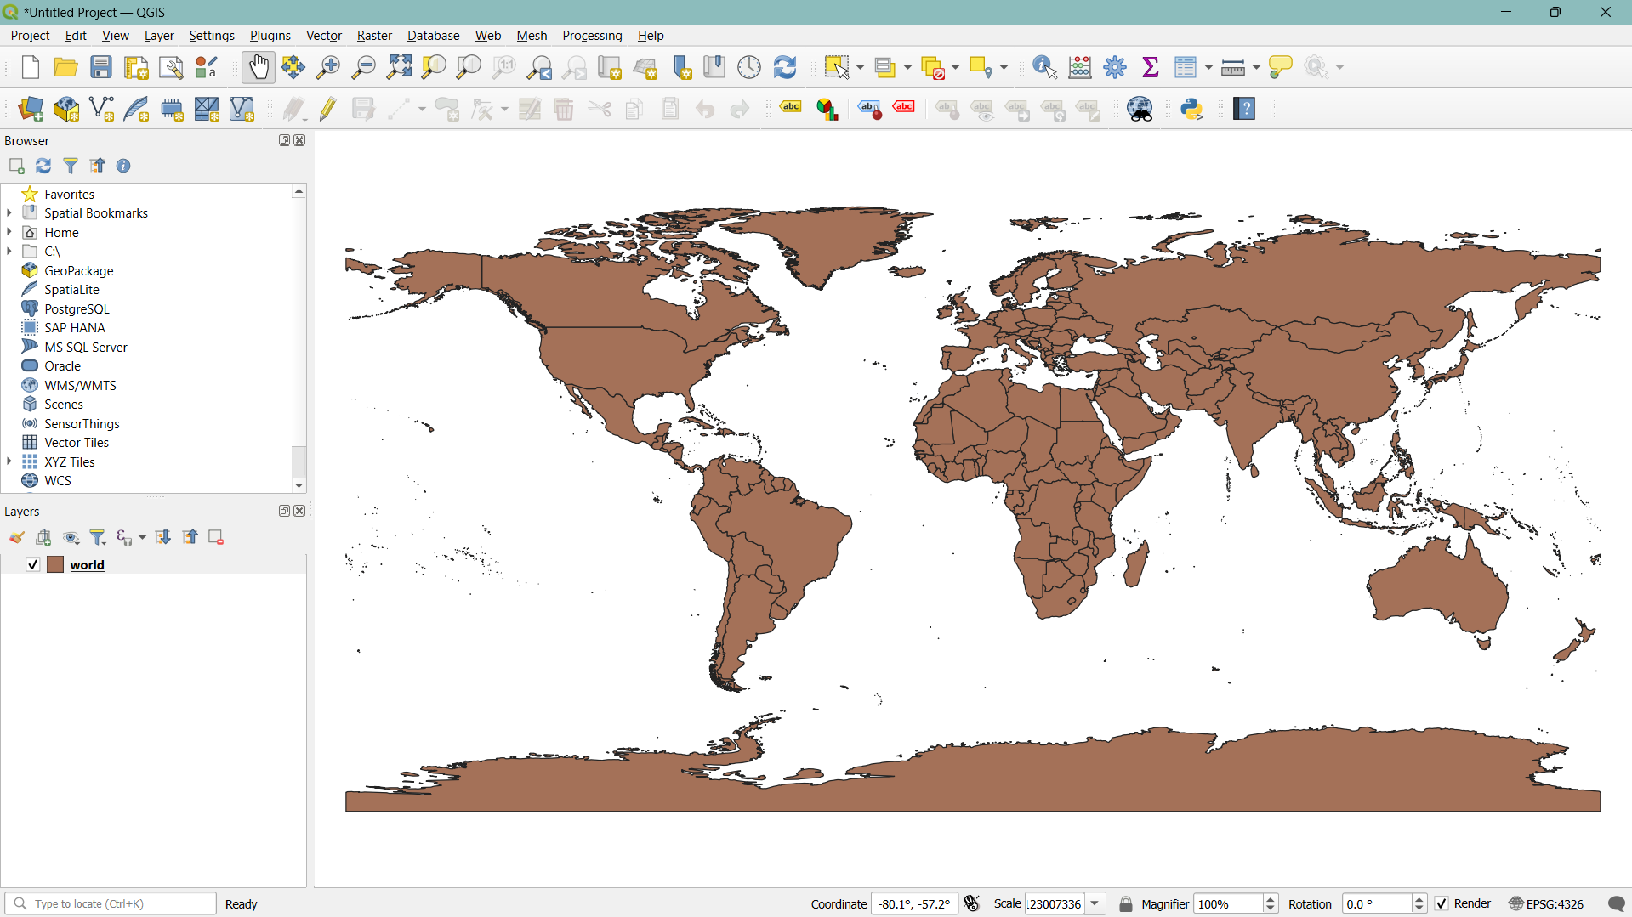

# Step 2: Open the Attribute Table

# Right-click on the layer in the Layers panel.

# Select Open Attribute Table.

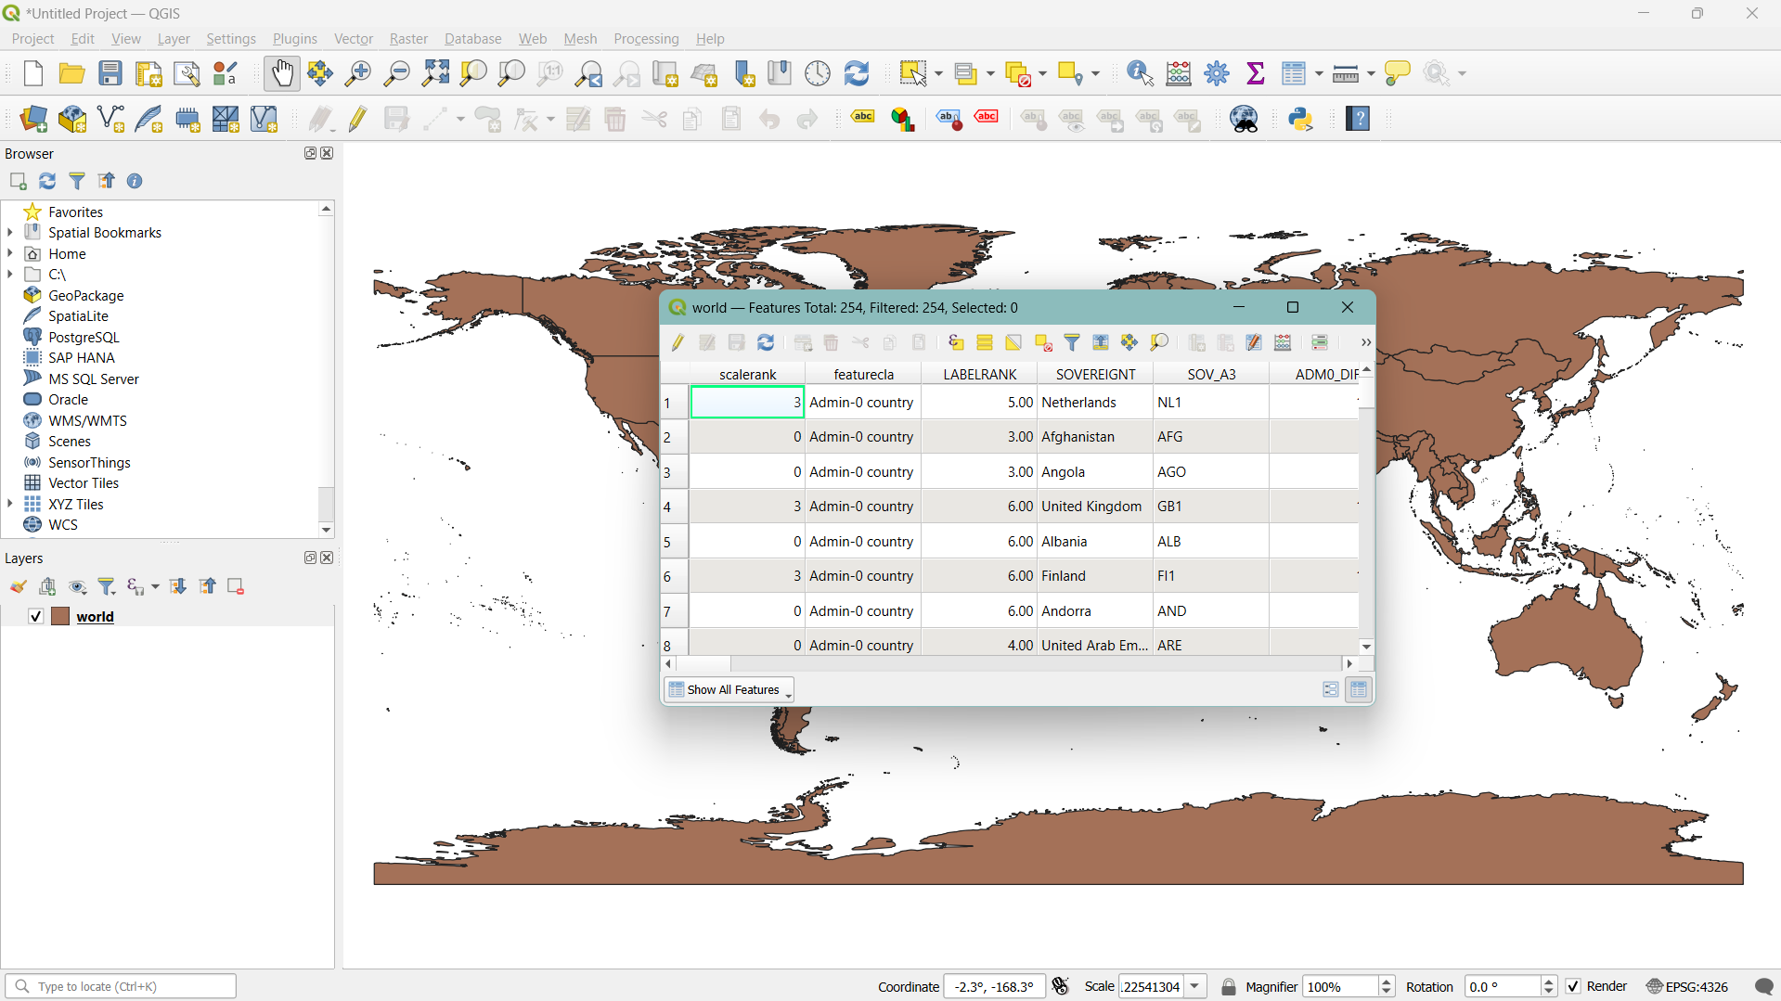

# Step 3: Add a New Field for Calculations

# In the attribute table, click on the Field Calculator icon (it looks like an abacus).

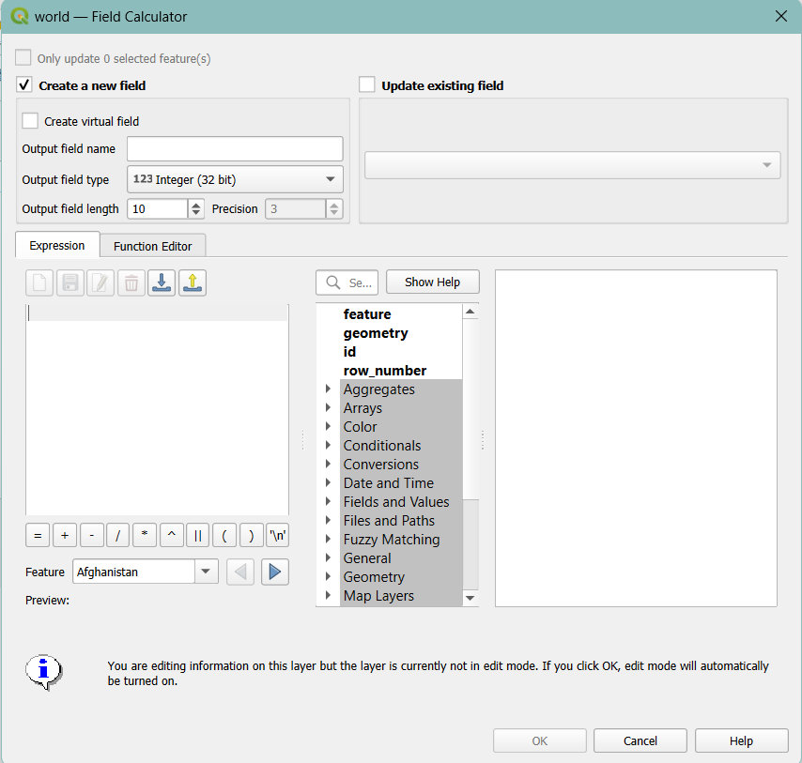

# Step 4: Calculate Area

# In the Field Calculator dialog:

# Check the option Create a new field.

# Enter a name for the new field (e.g., "Area").

# Set the output field type to Decimal number (real).

# In the Expression field, enter the following expression to calculate the area in square meters:

# $area

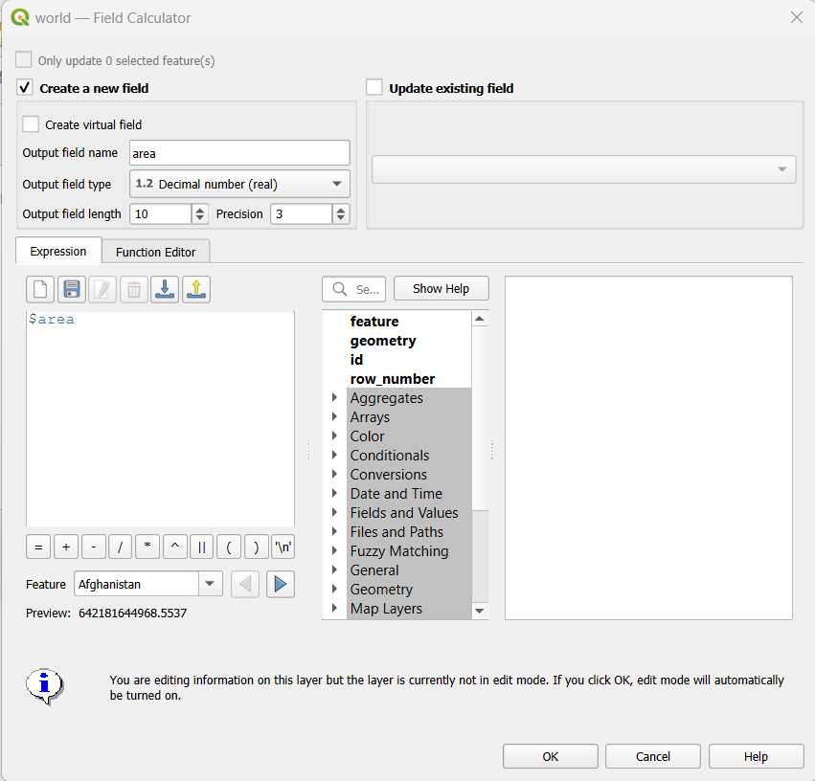

To get the area in hectares:

$area / 10000

Click OK to create the new field and calculate the areas.

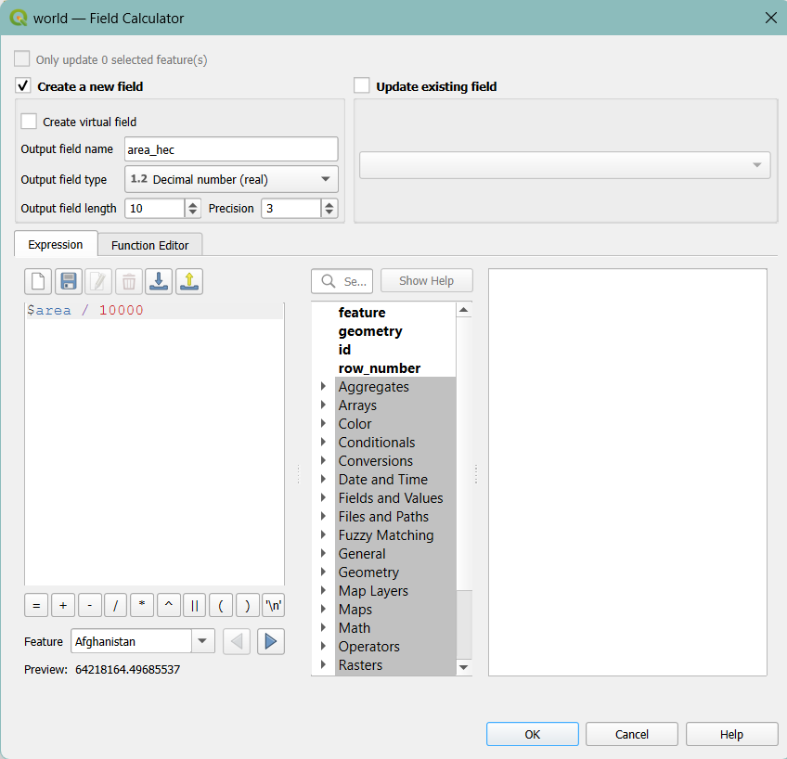

Step 5: Calculate Perimeter (for polygons):

perimeter($geometry)

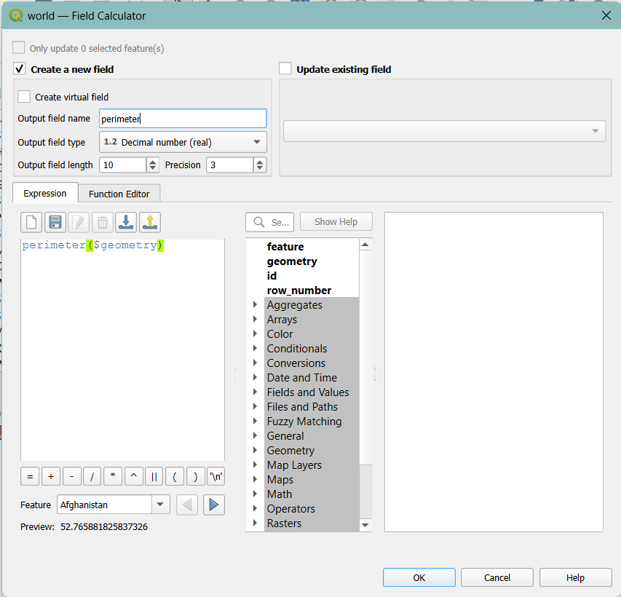

Step 6: Visualizing data

Area –

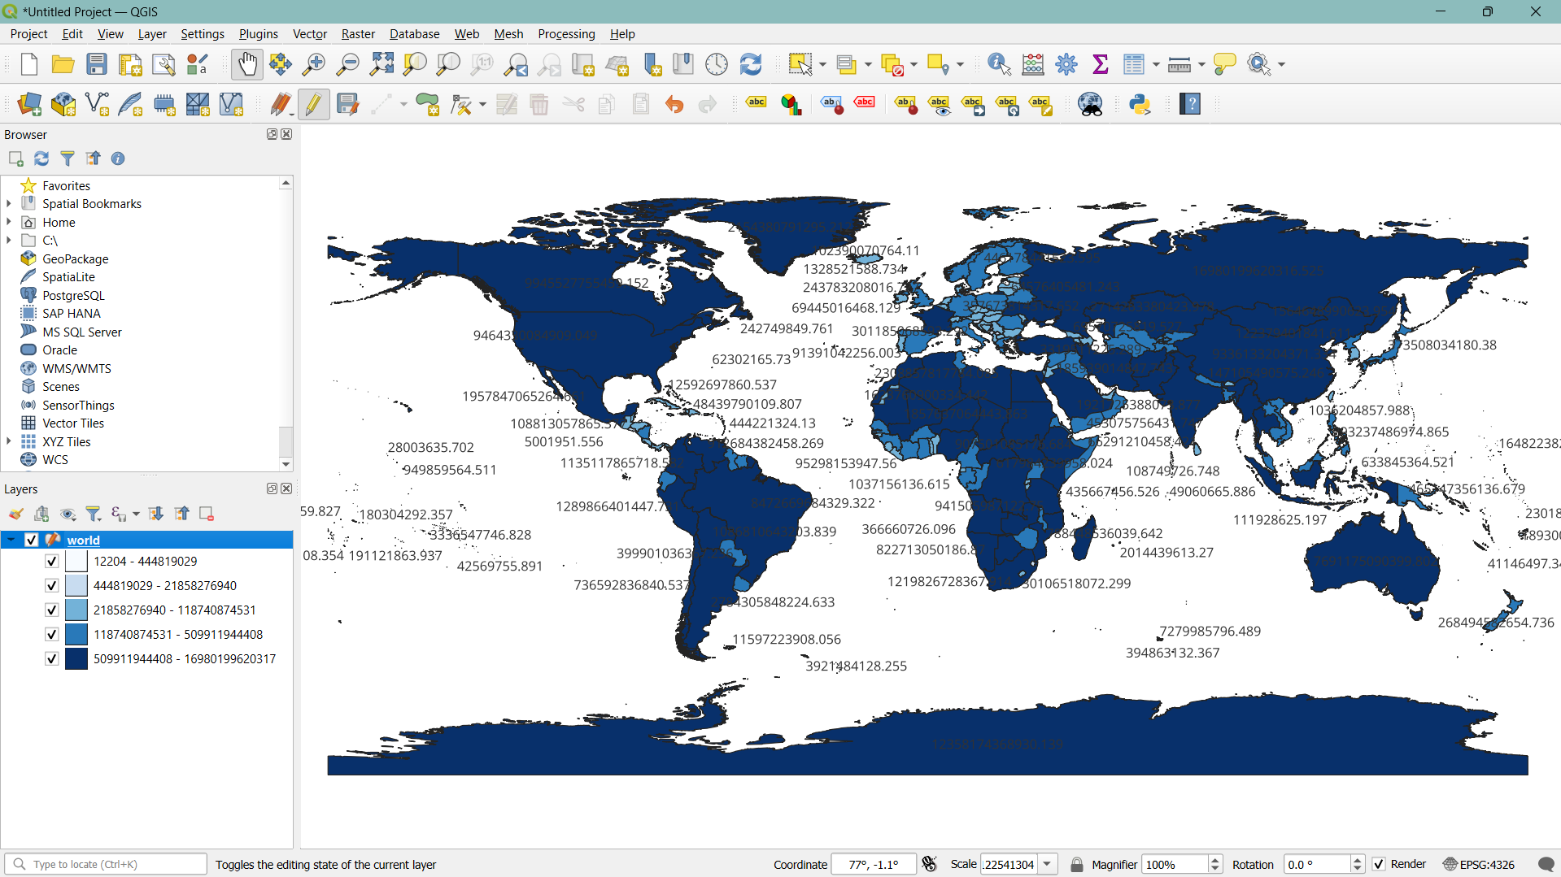

Area in hectares –

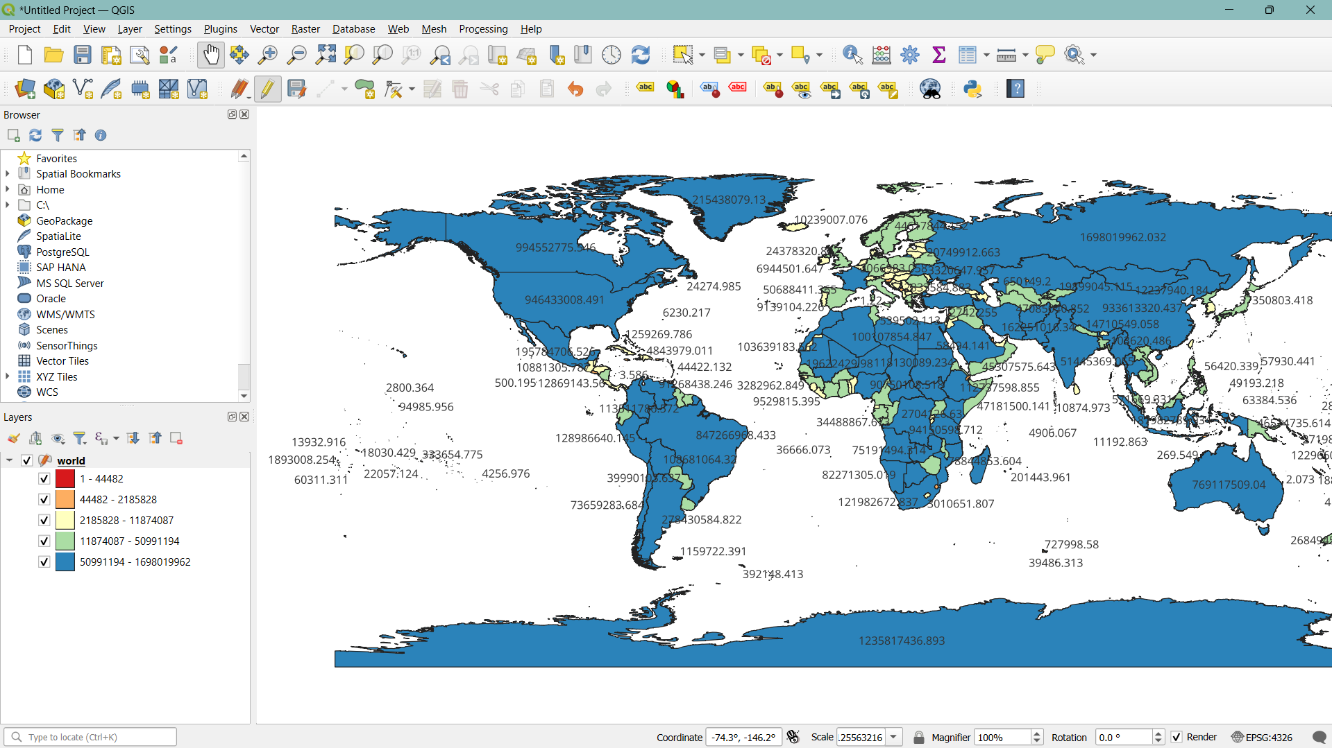

Perimeter –

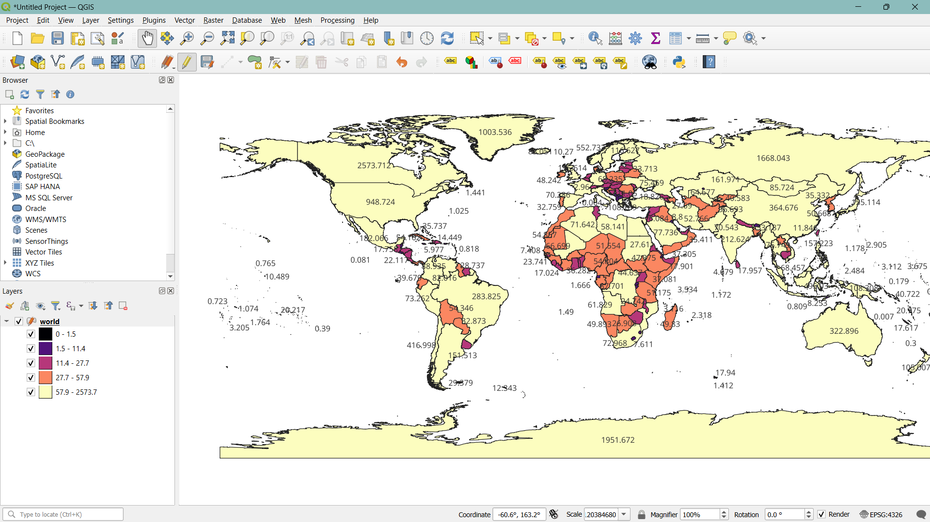

**Task: To work on other geometric properties like centroid using different expressions in the Field Calculator.**

# Platform used by the student: QGIS

# Following points should be written by students –

# Different Geometric Properties used in spatial data analysis.

# Few of the main geometric properties used in spatial data analysis –

# Area: The size of a surface enclosed by a polygon.

# Perimeter: The length of the boundary of a polygon.

# Length: The total extent of a linear feature.

# Centroid: The geometric center of a feature.

# Bounding Box: The smallest rectangle that contains a feature.

# Students need to write comments wherever needed.

# Conclusion:

# Spatial data analysis utilizes geometric properties such as area, perimeter, and length for vector data, and cell size and raster extent for raster data to understand spatial patterns and relationships. This analysis aids in effective decision-making, resource management, and problem-solving by providing valuable insights and visualization of spatial information.

**Post Lab Questions:**

1. **What are different geometric properties used in spatial data analysis on vector data with expression?**

* Area: $area - Measures the size of a polygon.
* Perimeter: perimeter($geometry) - Measures the boundary length of a polygon.
* Length: $length - Measures the total length of a line feature.
* Centroid: centroid($geometry) - Provides the geometric center of a feature.
* Bounding Box: boundingBox($geometry) - Gives the smallest rectangle enclosing a feature.

1. **What are different geometric properties used in spatial data analysis on raster data with expression?**

* Cell Size: raster.cellSize() - Dimensions of each raster cell.
* Raster Extent: raster.extent() - The spatial extent covered by the raster.
* Pixel Count: count(raster) - Number of pixels within a specific range or classification.
* Mean Value: mean(raster) - Average value of the raster cells.
* Standard Deviation: stdev(raster) - Measure of variability in cell values.

1. **What is spatial data analysis and write its advantages.**

Definition –

The process of examining spatial data to identify patterns, relationships, and trends using various techniques and tools.

Advantages –

* Pattern Identification: Helps in recognizing spatial patterns and trends.
* Decision Making: Assists in making informed decisions based on spatial relationships.
* Resource Management: Facilitates effective management of resources and land use planning.
* Problem Solving: Aids in solving spatial problems and optimizing solutions.
* Visualization: Enhances understanding through graphical representation of spatial data.